STOCK DATA ANALYSIS REPORT
Submitted for

BUSINESS FORECASTING METHODS AND APPLICATIONS

Submitted by:
(1814305002) ISHANI MAHAJAN
(1814304) GAURAV

Submitted to-
Dr. Nitin Arvind Shelke


L M Thapar School of Management

Jan-May 2024

INDEX

Sr No
Content | Page No

LIST OF FIGURES

Figure No. | Title | Page No.
2.1 | Block diagram | 12

LIST OF TABLES

Table No. | Title | Page No.
1.1 |  | 8

Note: List of Figures and List of Tables shall be on separate pages.

- ABSTRACT
The objectives of a project involving the analysis of stock data utilizing linear
regression, multiple regression, and polynomial regression methodologies can
encompass a range of aims, tailored to the specific context with the help of Python
and various libraries.
We have data of stock with variables of Date, Open, High, Low, Close, Adj. Close,
and Volume of 4 different stocks.
Working on stock data we can offer valuable insights into the relationships between
various factors and stock prices.
- Predictive Modelling - Linear regression
- Understanding Relationships -Multiple regression
- Non-linear Relationships - Polynomial regression
- INTRODUCTION AND RELATED WORK
The stock market can seem like a puzzle, with many pieces influencing stock prices. In this project, our goal is to use regression analysis, a tool from math and statistics, to understand how different factors affect stock prices. By looking at what others have studied about financial analysis, we've learned that regression techniques are helpful in understanding how stocks behave. We believe that by carefully analyzing stock data, we can make smarter decisions about investing our money.

We know that stock prices don't just go up and down randomly. They're influenced by things like how well a company is doing, news about the economy, and even people's emotions about investing. Regression analysis helps us see how all these factors work together to move stock prices. Our aim is to dig into this complexity and make it easier for investors to understand what's going on in the stock market.
- SOFTWARE USED
We have used Python for data analysis because it's versatile and easy to use. We also rely on some special helpers called libraries: Pandas, Plotly, Seaborn, and Scikit-learn. These libraries are like extra tools that make Python even more powerful.
With Pandas, we can easily organize and play around with our data, kind of like sorting it into neat piles. Plotly helps us turn our data into colorful charts and graphs, so we can see trends more clearly. Seaborn is another handy tool for making our charts look nice and professional. Lastly, Scikit-learn is like our secret weapon for building smart models that predict stock prices.
By using these tools together, we make sure our analysis is strong and accurate. They help us crunch through lots of data, spot important patterns, and make smart predictions about the stock market.
- METHODOLOGY
Our methodology involves several key steps:

- Data Collection and Preprocessing: We import stock data into a Pandas DataFrame and preprocess it for analysis.
- Exploratory Data Analysis (EDA): We conduct EDA to gain insights into the distribution and relationships between stock attributes.
- Regression Modeling: We apply linear, multiple, and polynomial regression techniques to model the relationships between stock attributes and prices.
- Evaluation: We evaluate the performance of our regression models using appropriate metrics.
- Visualization: We visualize the results using Plotly, Seaborn, and Matplotlib to facilitate interpretation.
- EXPERIMENTAL RESULTS
Our analysis yields findings:
- Descriptive Statistics: We observe the central tendency and variability of stock attributes across different stocks.

- Time Series Analysis: We visualize the time series of closing prices for each stock, identifying trends and patterns.

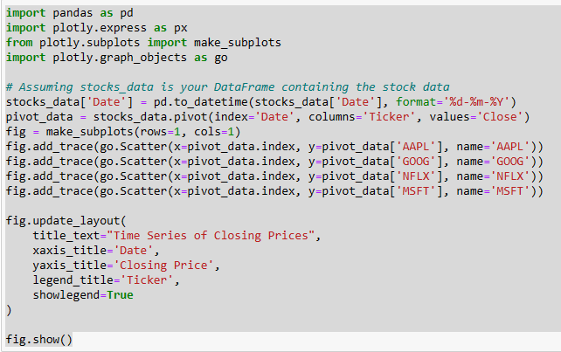
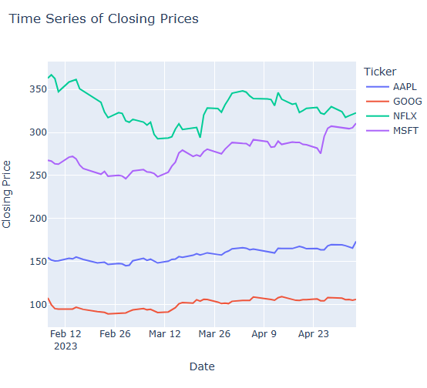
The x-axis represents the date, and the y-axis represents the closing price. The lines on the graph show the closing price of each stock over time.
- Overall trend: The closing prices of all four stocks appear to be increasing over the time period shown in the graph. This suggests that there is an upward trend in the stock market during this time.
- Stock price volatility: The lines on the graph are not perfectly straight, which suggests that the stock prices have been volatile over time. There have been periods of time when the stock prices have gone up and down.
- Comparison of stock prices: It is difficult to compare the stock prices of the four stocks directly because the y-axis does not start at zero. However, it appears that AAPL has the highest closing price, followed by GOOG, MSFT, and NFLX.

- Volatility Analysis: We quantify the volatility of closing prices, providing insights into market risk.
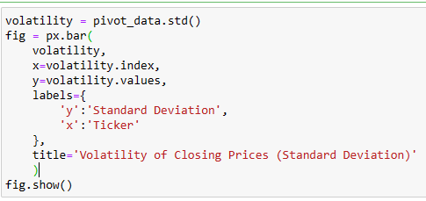
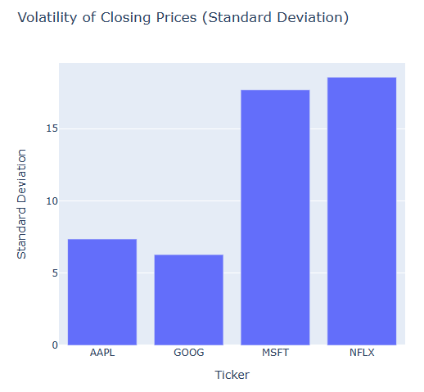
- AAPL: AAPL has the lowest standard deviation among the four stocks. This means that its closing prices were the least volatile over the time period.
- GOOG: GOOG has a higher standard deviation than AAPL, but a lower standard deviation than MSFT and NFLX. This means that its closing prices were more volatile than AAPL's but less volatile than MSFT's and NFLX's.
- MSFT and NFLX: MSFT and NFLX have the highest standard deviation among the four stocks. This means that their closing prices were the most volatile over the time period shown in the chart.
- Correlation Analysis: We examine the correlation matrix of closing prices, identifying interdependencies between stocks.
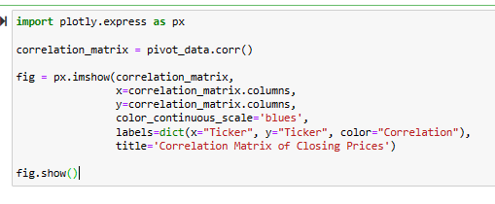
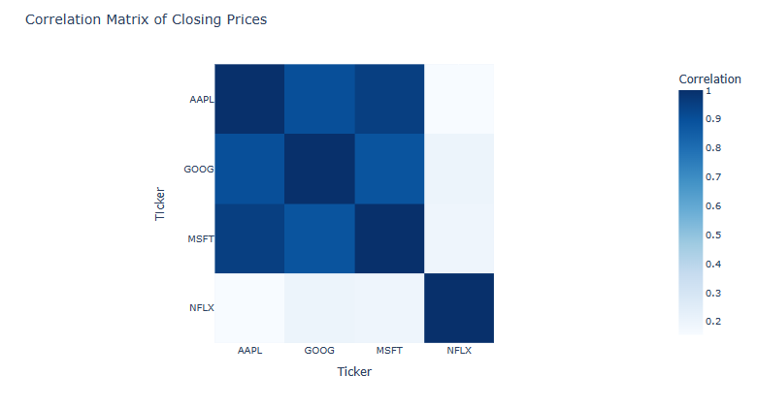

- Visualization: We visualize pairwise relationships between stock variables, revealing potential correlations.
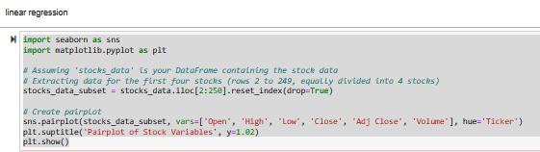
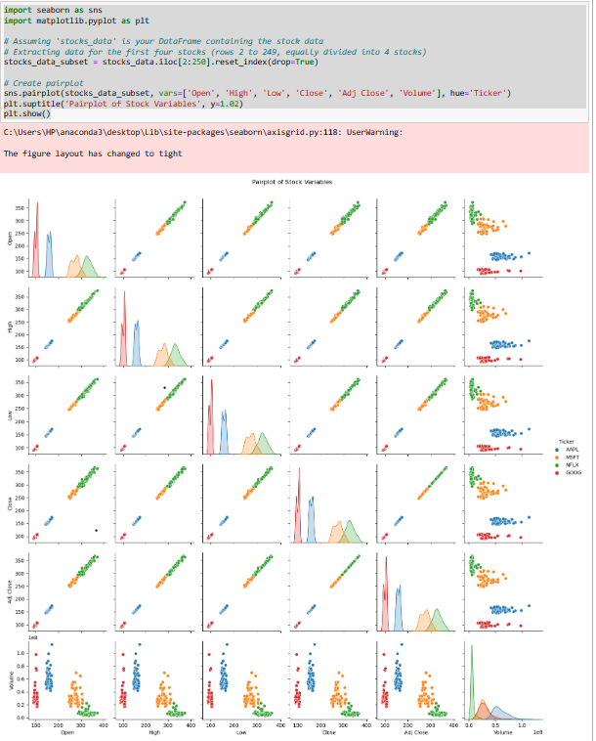

By looking at all of the plots in the pair plot, you can get a sense of the relationships between the different stocks. For example, you can see if the closing prices of two stocks tend to move together, or if they tend to move in opposite directions.
Here are some additional things to keep in mind when interpreting a pair plot:
- The pair plot only shows the relationships between pairs of variables. It does not show the relationships between more than two variables at a time.
- The scale of the axes can affect how the data is interpreted. For example, if the scale of the y-axis is different for two plots, it can be difficult to compare the spread of the prices for the two stocks.

- PCA Analysis: We employ PCA to identify patterns and reduce dimensionality in the dataset.

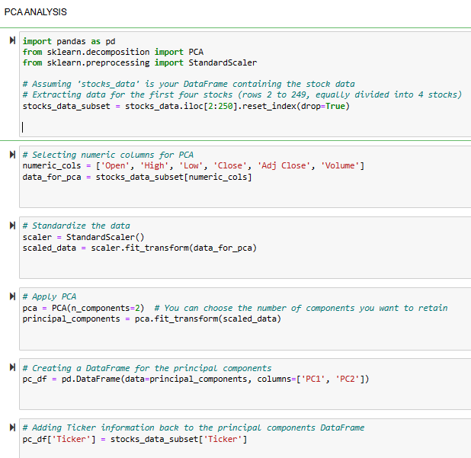
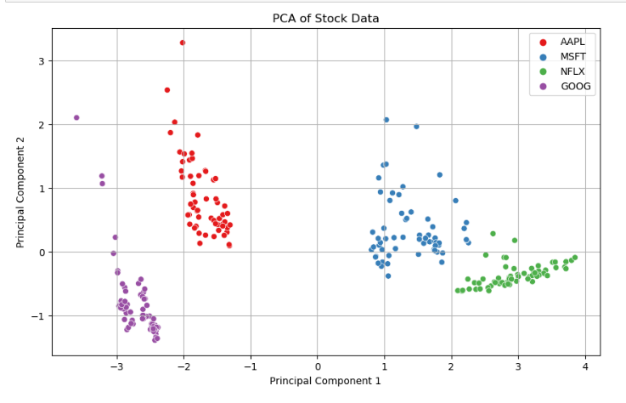
Dimensions (Components): PCA aims to reduce the dimensionality of the data while capturing most of the variance. In this case, it has transformed the original data (likely closing prices of multiple stocks) into two principal components (PC1 and PC2), which are uncorrelated and explain most of the variance in the data.
Stock Scores: Each data point in the scatter plot represents a stock. The position of a stock on PC1 and PC2 reflects its weights (or scores) on those principal components. These scores indicate how much a particular stock contributes to the overall variation along PC1 and PC2.
Positive/Negative Correlation:
- Stocks closer together on the biplot likely have similar closing price movements.
- Stocks on opposite sides of the origin (0,0) likely have opposite closing price movements, i.e., when one increases in price, the other tends to decrease.
Contribution to Variance:
- The distance of a stock from the origin (0,0) reflects how much it contributes to the variance explained by PC1 and PC2. Stocks farther away contribute more.
Interpretation in this case:
- AAPL and GOOG: These two stocks are close together on the right side of the plot, which suggests that their closing prices tend to move together (positive correlation) and contribute more to the variance along PC2.
- MSFT: MSFT is located farther away on the left side, indicating a different price movement pattern compared to AAPL and GOOG. It contributes more to the variance along PC1.
- NFLX: NFLX is farthest away in the bottom left, suggesting the least correlation with the other stocks and the most significant contribution to the variance along PC1, potentially indicating a unique price movement pattern.

- Decision Tree Classification: We use a decision tree classifier to predict stock labels, achieving high accuracy.
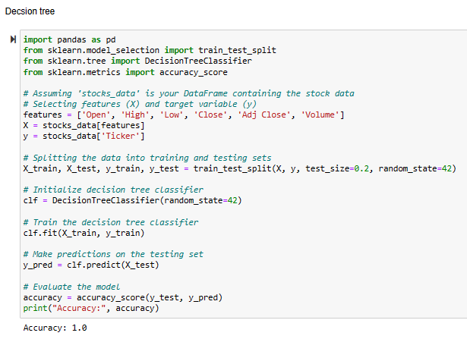
Breakdown of our Code:
- Decision Tree Classifier: The code trains a decision tree classifier to predict stock prices.
- Training and Testing Data: The data is split into training and testing sets. The model learns from the training data and its performance is evaluated on the unseen testing data.
- Accuracy Score: The code likely uses the accuracy_score function from sklearn.metrics to calculate the accuracy on the testing data. Accuracy represents the proportion of correct predictions made by the model on the testing set.
So, "accuracy 1" would indicate that the model perfectly classified all data points in the testing set. However, this is an unusual scenario, especially for financial forecasting. It's more likely that the accuracy would be a decimal value between 0 (completely wrong) and 1 (completely accurate).

- CONCLUSION
Our analysis has helped us understand more about how stock data works. Using regression analysis and visual tools, we've discovered some really interesting things about how stock prices move and how different stock attributes are connected.
Our findings help to get a clearer picture of what's going on in the stocks Market. This knowledge isn't just interesting - it's also useful for people who want to invest their money wisely. By understanding these patterns, investors and analysts can make smarter decisions about buying and selling stocks.
But there's still more to learn! We think there's room for more research to explore fancy new techniques and include even more factors in our analysis. By doing this, we can make our predictions even better and help even more people navigate the exciting world of the stock market.
- GitHub Repository Link
Minimum 5 reference is required (You may use the research article)

